Electronics and Computer Science Faculty of Physical and Applied Sciences University of Southampton

Alejandro Saucedo

5th December, 2013

sparse and group regression approaches

in portfolio optimization

Project Supervisor: Prof. Mahesan Niranjan

Second Examiner: Prof. Vladimiro Sassone

A progress report submitted for the award of

Software Engineering BSc

# Abstract

Since Markowitz introduced Modern Portfolio Theory in one of the most influential financial research papers, portfolio optimization has become a huge area of research in the financial sector. Numerous regression models have been devised to achieve better results since, however, all current models only consider only each stock as an individual entity of data. This paper takes a novel approach to portfolio optimization where financial instruments are analyzed as groups, rather than as individual stocks. Financial instruments are analyzed using prior knowledge of the underlyings, such as industry, sector, or any characteristic that allows for classification. Several group regression models are applied with the aim of finding better and novel results.

This paper contains thorough background research on various financial and machine learning models and terms which were required to understand and implement our group regression model approaches. The objective of this paper is to find out whether prior classification knowledge on each financial instrument could allow for more efficient classification models.

A new formulation was devised….

Some of the main models that will be analyzed in this paper are Value at Risk variations, the L0+L2-norm model devised in [0] Mahesan et al. (2013), sparse regression models (such as LARS and Lasso), and group regression models such as Group Lasso. In this document, a top-down approach will be taken to analyze and test the subcomponents that comprise these models.

Finally, these regression models will be applied to distinct sets of financial data through full-search and greedy model selection approaches in order to draw conclusions on the effects of these approaches.

# Contents

Abstract 2

Contents 4

1 Introduction 5

1.1 Background Research 6

1.2 Implementation 6

1.3 Analysis 7

1.4 Expansion 8

1.5 Testing 8

1.6 Conclusion 8

2 Background and Report of Literature Search 9

2.1 Mathematical Definitions 9

2.1.1 General 9

2.1.2 Group Notation 10

2.2 Financial Definitions 10

2.2.1 Financial Risk 10

2.2.2 GARCH Prediction Model 10

2.2.3 Autoregressive Integrated Moving Average 10

2.2.4 Modern Portfolio Theory 10

2.2.5 Value-at-Risk 11

2.2.6 Expected Shortfall 11

2.2.7 Tracking Error 12

2.3 Simple Regression Models 12

2.3.1 β-VaR 13

2.3.2 Norm Constrained CVaR 13

2.3.3 L0+L2 Model 13

2.3.4 Lasso Regression 14

2.4 Model Selection Approaches 17

2.4.1 Full Search 17

2.4.2 Greedy Search 17

2.5 Group Regression Approaches 18

2.5.1 Model Selection Approach 18

2.5.2 Group Lasso Regression 19

3 Implementation 22

3.1 Working Environment 22

3.1.1 CVX 22

3.1.2 SPAMS 23

3.2 Dataset Design 23

3.2.1 DataSets 23

3.2.2 Data grouping 24

3.2.3 Financial Mathematical Notation 24

3.3 Core Financial Formulations 24

3.4 Simple Regression Models 25

3.5 Sparse Inducing Models 26

3.5.1 Simple Lasso model 26

3.6 Individual-Feature Selection 28

3.6.1 Algorithm 28

3.6.2 Feature-Selection Implementation 29

3.7 Group Models 30

3.7.1 Group Selection 31

3.8 Sparse Group Models 33

3.8.1 Group Lasso 33

3.8.2 Sparse Group Lasso 35

3.9 Testing Environment 36

3.10 Algorithms Used 36

4 Expansion 37

5 Testing 38

6 Critical Evaluation 39

7 Conclusion 40

8 Plan of Remaining Work 41

9 References 42

# Introduction

Portfolio optimization has been a major research topic since it was introduced in Markowitz’s paper, Modern Portfolio Theory – one of the most influential research papers in the field of finance. Since its debut, this theory has been dissected, analyzed and expanded thoroughly, and has even expanded to achieve better results in portfolio optimization problems such as index tracking, enhanced indexation, absolute return, market neutral, between others.

Until this date, portfolio optimization models have only considered financial instruments as individual entities of data – that is, using only common regression models (e.g. linear, ridge, weighted regression models). In this paper, we take a completely novel approach on portfolio optimization, where we take into consideration groups of financial instruments as opposed to only the individual instruments. These groupings are achieved through prior knowledge of the financial instruments, such as financial sector, industry of the underlying company, or any characteristic of the instruments that allows for grouping.

Financial terms, concepts and definitions required to understand and implement these approaches will be given throughout this paper. Similarly, all the machine learning models, formulas and definitions will be dissected and explained in order to provide an intuitive understanding on the application and implementation of these group regression approaches.

This paper is structured in six main sections – namely, Background Research, Implementation, Analysis, Expansion, Testing and Conclusion.

The working code for the Implementation of this paper has been registered in an Open Source public licence, which is being hosted in GitHub at the time of writing, and can be downloaded at http://github.com/axsauze/sparse. Links to all the papers referenced by this paper, as well as graphs and all material related to this paper are also included in this repository.

## Background Research

Given the complex nature of this research topic, there was a lot background research required to obtain an intuitive understanding on the models and concepts related. This section aims to provide the reader with the core knowledge required on the financial, mathematical, statistical and algorithmic concepts, definitions and formulations related to this research topic.

Understanding on several financial concepts will be important to provide knowledge on the application of this model. This section provides the mathematical notations and definitions that will be consistent throughout the paper, as well as financial definitions and formulations, such Volatility, Financial Index, Modern Portfolio Theory, Portfolio Optimization, Index Tracking, Value-at-Risk, Conditional-Value-at-Risk, between others.

It will also be important to cover the machine learning and algorithmic models that are present in this research project. These are broken down and analyzed in order to provide an intuitive and clear knowledge. Models covered in this paper are Conditional Value at Risk minimization, Linear, Ridge, Weighted, Lasso and Lars regression, the L0-L2-norm model, and several group regression approaches. The algorithmic approaches taken are namely full-search and greedy approaches.

## Implementation

The aim of this section is to implement the models and concepts introduced previously in order to discover the effects of group analysis in financial data as opposed to individual stock analysis, and whether using this group knowledge allows for better results.

Each individual regression model is applied to Market Index Data for a specific window of time. Experiments are based completely on Index Tracking, and the results are given through the final Tracking Error. In few words, the index tracking minimization problem consists on finding a subset of stocks from a specific portfolio that behaves as similar as possible to the original portfolio (i.e. has the lowest tracking error).

Each model contains several constants that need to be adjusted to provide reliable and desirable results – some of these constants define level of sparsity to be achieved, as well as other characteristics. Several experiments will be carried out to find efficient values for these variable to provide reliable results.

Although stochastic data will be used initially, the main financial data set used in this paper is the FTSE100 (Pronounced ‘footsie’ 100) – which is a share index of the 100 companies listed on the London Stock Exchange with the highest market capitalization.

The initial approach for group analysis of stocks is applied through a greedy approach similar to the one in [0], however it will be explained that most of the times it is possible to apply full search approaches, as the number of groups tend to be much smaller.

Group regression model applications in financial data are also visited briefly in the implementation section of this paper, however these are expanded in the Analysis and Expansion sections.

## Analysis

In this section, this paper aims to provide a thorough and in-depth analysis of the results obtained in the implementation section.

The objective of this section is to provide the effects of Index Tracking applications when groups are taken into consideration.

This section provides a perspective on the differences between the models being considered, and aims to provide a more qualitative-oriented, intuitive analysis on the results obtained (As opposed to the more quantitative perspective of the previous section).

Several real-life examples as well as applications are considered in this section to provide a clear understanding on these individual and group approaches, and provides several ideas to introduce the next section – Expansion of group approaches in portfolio optimization.

## Expansion

Although in this paper we focus on this Market IIt is certainly possible to expand this into any Market Index, or even custom portfolios containing distinct types of financial instruments (e.g. commodities, options, bonds, etc).

In order to expand on the application of the L0+L2-norm model, it is necessary to obtain further knowledge of the specific financial concepts required. These concepts include commodities, currencies, high frequency and real time data.

The currencies market varies a lot from the stock market, and some of its characteristics would make the application of this model ambiguous – an example would be the constraint that the model requires which does not allow shorting – however, in currencies, although one might go long in one currency (Such as long on EUR/USD), one could say it is shorting on the other (such as short on USD/EUR).

Commodities in the other hand have a seasonality characteristic, in which financial commodities such as specific fruits might have drastic increase or decrease of price due to the time of the year due to numerous environmental factors.

High frequency data might require an implementation in a different programming language and environment due to the considerably larger sets of data that will need to be processed. Real time data in the other hand, will require the model implementation to be revisited, as the local optimal nature of the greedy algorithm would not allow for updates as new data comes in.

## Testing

## Conclusion

# Background and Report of Literature Search

In this paper we aim to discover the effects of taking into account groups of financial instruments in portfolio optimization problems. For this, it is required to understand several financial terms, as well as the Machine Learning approaches used in this paper. This section aims to provide the reader with the core knowledge required on definitions, formulas and concepts related to the topics that comprise individual and group regression approaches in financial instruments.

This project was inspired by [0] Mahesan et al. (2013), where an innovative regression model was introduced – namely the L0+L2-norm model. The objective this previously mentioned paper is to find an optimal subset of stocks from a Market Index with the least tracking error, which is approached through a greedy algorithm. In this paper we expand this concept to various regression models, and we introduce grouping of financial instruments as an input for these models. These terms and regression models will be explained further subsequently.

## Mathematical Definitions

### General

We will use σ to refer to the volatility of a financial instrument (i.e. the standard deviation of the daily returns of a specific financial instrument).

Norms will be referred as L–norms, where as .

The statistical and mathematical notations used in this paper are all considered within a specific time window t = 1, ...,T and a number of assets n.

Input data is of the form **R**t∈ **ℝ**n= (**R**t,1, **R**t,2, …, **R**t,n)Τ where **R** is a matrix where each column is a vector of returns of all the assets of the portfolio at time t.

Our target data is of the form  where ***I***is a Market Index (i.e. a share index of the n companies listed on a specific Stock Exchange with the highest market capitalization) and **π** ∈ **ℝ**n = (**π**1, …, **π**n)Τ is the parameter to be learned, and consists of the proportion of the total capital invested on each asset in the portfolio.

This paper will be implicitly limited by the constraints **π** > 0 which ensures that it is not possible to sell assets that are not owned (shorting) and .

### Group Notation

When dealing with groups, we will have groups of size , where .

Our stocks will be grouped in these m groups of size , which means our data **R** is in groups **,** where and .

Although our Index Portfolio would be referenced with the same variable **I**, a new group definition is now introduced as , where are the parameters to learn that belong to the stocks in group .

For the new group formulation proposed we will need to introduce the concept of superscripting present in programming in order to reach specific elements in matrices and vectors through indexing. In this paper we will use the pseudo-code notation , where **X** is a matrix of any size, **x** and **y** are vectors of the same size containing the positions in the Matrix to be superscripted, and they are of the form . A column can be used to denote that all columns or rows are selected, so would superscript all the row elements for columns contained in the indexes **y**.

For indexing we will use a variable that will denote the indexes of the stocks of each group. For example, if group contains stocks 3, 5, 6, etc, then = {3, 5, 6, …}. This allows to introduce the logical biconditional.

The final notation required for the new proposed formula is the sum of all the columns or rows as where r is the number of rows in **A** and c is the number of columns in **A**.

## Financial Definitions

### Financial Risk

The definition of financial risk is the potential loss or uncertainty from an investment, and can be measured through mathematical and statistical models. A factor that is often used when measuring financial risk is Volatility. The volatility of a financial instrument is the standard deviation of the historical returns.

### GARCH Prediction Model

### Autoregressive Integrated Moving Average

### Modern Portfolio Theory

In finance, portfolio optimization is an extremely popular and revisited concept since its debut in the original paper by [1] Markowitz(1952), ‘Porfolio Theory’. More widely known as Modern Portfolio Theory, MPT consists of a minimization on the risk for a given level of expected return through choosing the proportions of the assets that comprise the portfolio. A portfolio is a compilation of assets where a percentage of capital is invested. In this paper we will be basing ourselves on Market Indices, which are portfolios of the best performing assets in specific stock markets.

Using input data over a range of time **T** for **n** assets, this Markowitz portfolio optimization formula minimizes on the portfolio variance given by, where **π** is the proportion invested on each asset, and **R** ∈ **ℝ**nxn is a covariance matrix of asset returns. The amount of expected return is given by *γ*, and a vector of expected returns for each asset is given by ***r*** ∈ **ℝ**n. This model revolutionized portfolio theory since its debut, and has been thoroughly revisited since. The L0+L2-norm model is somewhat a modified and improved version of this model.

### Value-at-Risk

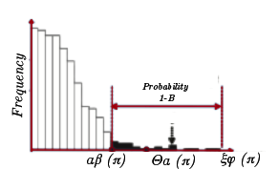A very important risk management model in finance is the Value-at-Risk model, or VaR [2] Philippe (1996). The most common application of Value-at-Risk is the β%-VaR. Given a percentage β% and a set of historical prices, we can build a frequency table which we assume has normal distribution, and then we can estimate the loss that we are β% sure that will not be exceeded.

Mathematically, given a confidence index α based on β% (i.e. 95% would be 2 standard deviations), a mean μ and a volatility σ, we can compute the model presented in [6] Mina et al. β%-VaR from a portfolio as follows:

Value-at-Risk is excellent when dealing with raw calculations from a given volatility, however it lacks of convexity characteristics, making it hard to optimize, and hence unattractive for minimization problems.

### Expected Shortfall

β-Conditional-Value-at-Risk, also known as Expected Shortfall, is the conditional expectation of losses above that β%-VaR – in other words, the probability that a specific loss will exceed the β%-VaR. Unlike VaR, CVaR has many desired characteristics such as convexity, that will allow for the definitions required for the definition of the L0+L2 model.

To define this, we base ourselves in the mathematical notation in [Akiko 2010] and in the logic of [4] Rockafellar R. et al. (2000). We initially base ourselves in a regression problem to obtain a linear function approximator y = (w,x) + b from m = 1, ..., M samples (xi, yi). Our variables x ∈ **ℝ**nand y ∈ **ℝ**nare our input and output values respectively and w ∈ **ℝ**nand b∈ **ℝ**are the variables to be learned.

### Tracking Error

In this paper, we will base all our calculations in a very commonly used loss function – the Tracking Error. Tracking error is very intuitive, especially when seen graphically – it basically measures how similar a portfolio A behaves to a portfolio B. We will refer to tracking error as ξφ, t(**π**) defined as:

This tracking error function will also be used to measure the results of the accuracy of our model compared to other models proposed.

## Simple Regression Models

Once defined out loss function, in this case, Tracking Error, we assume we an get probability of a specific result of by computing ρ( This allows us to define a function Θα(**π**) that gives us the cumulative distribution for our probability loss function ρ( given a given confidence α. This is, in other words, the probability of ξφ(**π**) not exceeding a threshold given by α. The function θα(**π**) is defined as follows:

Finally, now that we can calculate the cumulative distribution of our loss function we can obtain the definition of our β-VaR formula defined as:

### β-VaR

Now that we have obtained β-VaR, or the lowest percentage amount that we will be β% sure that will not be exceeded, we can define the CVaR as the average loss **exceeding** VaR. As proven in [4] Rockafellar R. (2000), the convex nature of CVaR allows for a minimization definition as follows:

Where when t > 0 and when .

### Norm Constrained CVaR

It is proven in [1] that this CVaR minimization is equivalent to the Support Vector Regression algorithm, implying optimality, and also includes a proof that allows us to introduce the variable , where sets a constraint to make the portfolio sparse, not allowing proportion values for each asset bigger than This also allows us to introduce the variable **zt,** where **zt** will simplify the implementation of the problem in our algorithm. This allows us to get our final definition of our CVaR minimization formula, which is referred as the norm-constrained CVaR:

s.t.

### L0+L2 Model

The L0+L2-norm model, as its name implies is based in a combination of the L0-norm model and the L2-norm model balanced with two input constants – namely τ and C0. The main goal of this model is to find a subset of size C0 (L0-norm constraint limited by ) from an initial portfolio, which behaves as similarly as possible to the initial portfolio (L2-norm constraint given by ). In order to explain this model, we need to introduce its subcomponents, which include Index Tracking, CVaR minimization, cardinality minimization and portfolio optimization, together with several financial and artificial intelligence concepts. The **L0-norm** component of this model is what increases the time complexity of the algorithm into an NP-Hard problem, hence why we need to have a Greedy approach.

As it can be observed, the norm constrained CVaR provides us with the **L2-norm** component of the L0+L2-norm model, which allows to re-define the L0+L2 model as follows:

s.t.

This allows us to observe the clear division between the L0-norm given by the cardinality constraint and the L2-norm given by the density constraint . These two norms are controlled by the variable . If , the model would behave as a L2-norm constrained model, and = 0 would give use an L-0-norm constrained model only. In [0] Mahesan et al. (2013) the constraint is not taken into account, hence in that case, when , the optimal solution exists when all the values of .

### Lasso Regression

Before proceeding to the introduction of the group regression methods, it is necessary to introduce some final concepts – one crucial one is the Lasso Regression model.

The Lasso regression model is comprised of a sum of squares, plus a scaled sum of the absolute value of the parameters – using our variables for Index, Return portfolio and weights, our model would be defined as follows.

s.t.

At first sight, it may seem very similar to the L0+L2-norm model introduced previously, however, what makes this model stand out is the second coefficient – namely the scaled sum of the absolute value of the parameters, which, different from the past model, this coefficient controls the sparsity of our final .

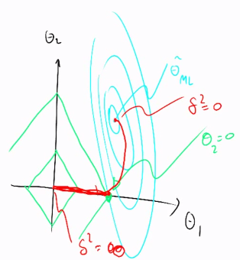

To visualize this we’ll take n=2 as an example, which is pictured in the figure 1 on the right, where the x axis holds the value for our and the y axis holds the value for .

The center of the green diamond represents the point of () when , and the center of the blue circle represents the point when .

The red path denotes the value and take as changes value. It can be observed that when , will be equal to the maximum likelihood of , denoted in blue by which is the result of the first term of our equation. When , the values of will need to be as small as possible in order to minimize our cost function, which will result in our point in the origin.

Figure 1

Figure

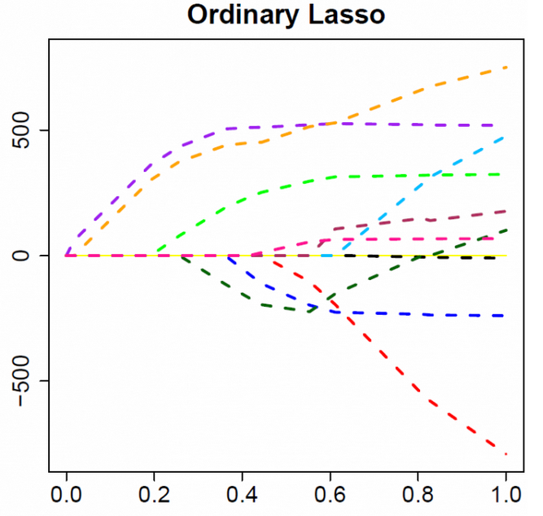By differentiating our cost function and equating it to zero, we find that many of our variables become zero – this is shown in Figure 2

Going back to figure 1 we can observe this behaviour when our blue circle intersects the corner of the green diamond. It is proven that intersections between these two are very likely to happen in the corners – which implies that one of our parameters has taken the value of zero – in this example, our parameter takes the value of zero when the red line intersects the x axis.

Figure

Intuitively, we will build an algorithm that initially takes a guess for all our parameters, then it will proceed to calculate the optimal value of each of the parameters using the (partial?) derivative of our cost function, and repeat this until it converges.

The reason why the last term has not been derived yet is because it consists of an absolute value – for this, subdifferentials will be used. In order to simplify the formulation shown, we will make the following assignments.

This would give us a much simpler formula to expand on its subdifferential, which consist of the following:

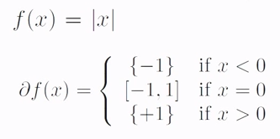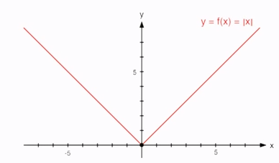Basically, with a subdifferential, we have a point which cannot be differentiated normally, as we would require a single gradient to explain a subset of gradients – in Figure 3, our point would be the origin, and we would have to define the differential of our formula as:

Figure

So, our formulas would consist of exactly the same format, but instead we would use our variables a, b and as follows:

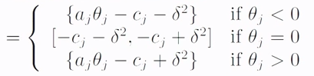

Now, by setting our values to zero, our estimate can be calculated by setting these differentials to zero for each of the , which gives us the following estimates:

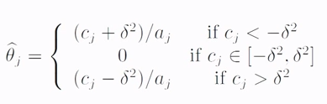

Knowing this estimate now allows us to implement the simple Lasso Algorithm in a very simple manner:

1. **Initialize** (Can be either random, or with something like ridge, etc)
2. **Repeat** until converged
   1. **For** j = 1,2, … , d DO
      1. **if**
      2. **elseif**
      3. **else**

## Model Selection Approaches

### Full Search

### Greedy Search

#### Forward Search

#### Backward Search

#### Forward Search Application

Due to the exponential complexity of the problem in [0] Mahesan et al. (2013) (i.e. to find an optimal subset of stocks from a given Market Index), it was very limited when it comes to even relatively small portfolios. Given that the average Market Index is composed of at least 100 distinct assets, this makes the implementation of a full search is almost impossible.

For this reason, a greedy approach was taken - namely, this was done through a forward model selection algorithm, where one optimal stock is chosen and added to the subset on each step until the subset reaches the desired cardinality.

Formally, the model is formulated as a subset selection, where each step, a locally optimal asset is chosen and added to the portfolio. The algorithm proposed in [0] Mahesan et al. (2013) is converted into a subset selection problem defined as follows:

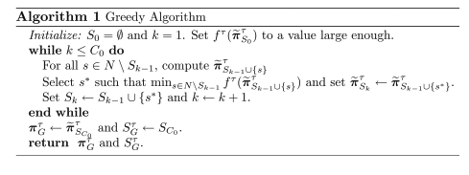

To apply this algorithm, we begin with an empty set, then for all the available stocks, we add one and run the L0+L1-norm model on each. We then calculate the tracking error for each, and select the asset with the lowest tracking error as our local optimal. We do this until the cardinality of our set reaches the L-0 constraint C0.

## Group Regression Approaches

Now that the most important key points have been introduced in the previous sections of the background research, it is possible to proceed to explain the approaches that have been considered in this paper to implement group selection in sparse and non-sparse regression models.

For a clear definition on the mathematical notation used for group lasso, please refer to section 2.2.1.

### Model Selection Approach

Before considering complex group regression models, this paper considers an approach based in the approach in [0] Mahesan et al. (2013) that initially inspired this research project – mainly it is being referred to the forward-search approach that was taken to select a subset of stocks from a Market Index with the lowest tracking error.

As it was revisited in the last section, the approach taken in [0] was a greedy, forward-search approach, and this was the choice over a full-search approach due to the NP characteristics of the subset selection problem. Given that stocks are considered individually, and the Market Indexes vary from 100 to 500 stocks, the time complexity of this problem would be exponential on the number of stocks to consider, which would not allow for a full-search approach.

This section proposes to reduce this individual stock subset selection problem reduces to a group subset selection problem, and assuming that our group number does not consists of a large amount of groups (e.g. more than 20), a full-search approach is actually possible, as we could have a full subset selection on our groups.

Similar to the previous algorithm, we can select any regression model and implement a full-search group subset selection as follows:



Similar to results presented in [0], with this full-search algorithm, we would be able to select a subset of financial instruments from a market index based on prior knowledge on the instruments that allowed us to create the groupings.

### Group Lasso Regression

A problem with the approach taken in the previous section is that model selection does not allow for varied weightings on each of the groups – instead it can only either include or exclude them completely.

#### Simple Group Lasso

This is when group lasso regression comes in - Now that we have understood the basic Lasso Regression, it can be easily expanded to a group approach, where the variables are assumed to be clustered in groups, and the values of Euclidean norms of the parameters in each group is used as opposed to each individual ones. This would drive all weights in the groups to zero together, providing group selection.



Group lasso was proposed by a very interesting paper, Yuan & Lin (2007) [REFERENCE], in this paper, we adapt it to our financial data formulation, which is defined as follows:

s.t.

Intuitively it can be observed that this model follows the same methodology than the individual Lasso model presented earlier – the only difference is that this formulation acts on data as groups of stocks, as opposed to individual stocks. If the group size for all groups is one, this problem would reduce to a simple individual Lasso model [REFERENCE NOTE ON GROUP LASSO]

Similar to the Lasso formulation, if the value of is too high, group sparsity would be forced in the enforced in the prediction vector (i.e. several groups would get a zero weighting).

#### Sparse group lasso

The only problem with the simple group lasso is that all the features in each group are modified equally, which means that there is no sparsity within the elements inside a group – if one group of features is non-zero, then all the features in the group would also be non-zero as well.

An innovative model is proposed in [REFERENCE A PARSE GROUP LASO] which not only provides the sparsity between groups, but also provides sparsity within individual levels. This is known as the Sparse Group Lasso, which is defined as follows:

s.t.

As it can be observed, the only difference in this formulation is the last term included, which is simply the L1-norm regularizer (sum of absolute values) found in the simple single-feature lasso model. This term, together with our variable which balances the ratio between which this regression model considers group sparsity and individual feature sparsity.

This model is revisited again [REFERENCE A NOTE ON GROUP] where another clever implementation of the Sparse Group Lasso is proposed. In this implementation, the initial is coefficient is dropped, together with the variable, and the variables and are introduced:

s.t.

Both our formulas is basically the sum of convex functions, which by result makes this function convex, allowing for finding a minimum – which gives us the ability to implement it in this paper for our Index Tracking problem.

## Zero-Constrained Group Lasso Application

The biggest challenge in this paper was to come up with a formula that does not require the inner summations that most implementations include, as the CVX library used cannot process the inner loops required such as the cofactors and **.** In order to come up with a solution, a new constraint was implemented which allowed us to solve this equation with only matrix multiplications – this constraint is explained below.

For this section we will require the variable introduced in our mathematical notations where - it should be obvious that the converse also applies. Intuitively,is a vector containing a set of superscripts which refer to the indexes of the stocks in group g.

It is worth mentioning that for this implementation we will be using the function sum(x,i) for the sake of simplicity. This function was introduced in the first section of this paper, and outputs the sum of the rows (i=1) or columns (i=2). The sum of the columns or rows of any matrix can be represented with a matrix multiplication of a column or row vector of ones respectively, however, this function will be used for making the explanation simpler.

Initially we needed to remove the cofactor consisting of the sum of the weighted subset of groups and change it for a cofactor that achieves the same in only matrix multiplications – our solution proposed is where . In simple terms, can be seen as an n by m (Number of stocks by number of groups) matrix, where each row contains the weights for a specific group in its respective index position and the rest of the elements are zeros.

To provide a more clear understanding of this, lets assume , we have m=2 groups where which gives us and These definitions allow us to build as:

With this we can relate our new introduced terms to the previous implementations of the group lasso – it should be obvious that . It should also be noted that in this example we also follow that , however we will need to introduce a constraint to make sure that this is always the case.

Now that we obtained a way to represent this cofactor as a single matrix multiplication, we need a constraint that ensures that always - that is, to make sure that all the elements in our variable are always zero if they do not belong to their respective group. Following this definition, we define to be the set containing the indices of the elements that are **not** in group g. Formally, we define **.** This allows us to introduce the constraint that makes this implementation possible, which is:

The only thing left now is to make the term suitable for our operations. The only thing we will require is a way to calculate the L2-norm of each column or row, rather than to the whole matrix. This is a very simple thing to do, which can be achieved by doing where we square all the elements of A, then get the sum of the columns, and finally square. This allows us to transform our second cofactor into:

sum(\*)

With this new constraint, and this new second term, it is possible to introduce the Group Lasso and Sparse Group lasso models that will be used throughout this paper:

sum(\*)

s.t.

Which is equivalent to the lasso formulation presented earlier, however, all the computations are all done through matrix multiplications, which makes it suitable for our implementation.

# Implementation

This section assumes that the reader has an appropriate understanding on most topics covered in the background research, and contains the implementation of the models and algorithms presented in the previous section.

This section begins with a description of the developing environment in which the code snippets were ran and tested, as well as information on the mathematical libraries used to obtain such results.

As mentioned in the introduction, the working code for this section has been registered on a public Open Source licence, which at the time of writing is being hosted in GitHub, and can be downloaded at http://github.com/axsauze/sparse.

## Working Environment

All the experiments in this paper were ran in a MacBook pro with OS X Mountain Lion 10.8.5, Intel Core i7 2.9 GHz processor, with 8 GB 1600MHz DDR3 SDRAM.

All code is written in Matlab R2014a, and two main libraries were used for linear regression computations – namely CVX and SPAMS. Details on compilation and installation of these can be found in the main repository.

### CVX

CVX is a Machine Learning library for Matlab that provides modelling tools that allow the programmer to specify constraints and objectives using standard Matlab code. This library allows great flexibility when it comes to solving simple regression problems such as least-squares, weighted regression, ridge regression, etc.

The CVX library would allow us to translate simple regression problems as follows:

|  |  |
| --- | --- |
|  |  |

This library will be used for most of the individual-feature regression models, and will be of great work in the testing.

### SPAMS

CVX does not have group regression support, and libraries that support group regression models are very scarce, but fortunately, the Sparse Modelling Software (SPAMS) library released in 2010 contains a great set of tools that allow for optimization with sparsity inducing penalties. These tools are based on a paper released by the same creators of this library [REFERENCE OPTIMIZATION SPARSITY], which contains in-depth detail on all of the sparse regression models included in this library, together with several algorithmic approaches and optimization methods.

Although this library takes several approaches to achieve convergence in its constituent regression models, Lasso related models utilize an algorithm devised in [REFERENCE FISTA] which comes from the ISTA (Iterative Shrinkage-Thresholding Algorithms) family of algorithms – namely the FISTA iterative method. This method is used in signal image processing due to its much greater converging speed.

There have been however, slight issues with the use of this library. Given that in this paper accuracy is much more important than speed of convergence, it is unfortunate that it’s not possible to utilize distinct iterative methods for convergance when implementing Lasso and Group Lasso variations. Another inconvenience is that this library is more of a black box, and although this might be beneficial in terms of speed, this really limited this implementation. These matters will be discussed further, together with potential solutions in section 7. Expansion.

## Implementation Design

### DataSets

Experiments are carried out on various sets of data in order to provide more robust and reliable results. Sets of data consist of both, real and stochastic financial data.

The data sets used in this implementation consist of a financial time series containing the returns of a specific Market Index, together with the individual price of its constituent stocks.

#### Market Financial Data

In this paper, the Market Index to be analysed will be the FTSE100, together with the n=100 stocks that comprise it. The time window to be analysed will consist of T=274 working days, starting from 1st of November, 2011, until the 1st of December, 2012. This data is retrieved using the Yahoo finance API.

#### Stochastic Financial Data

Stochastic data will have the same format as the real financial data – namely a set of n=200 stocks, with it’s Index Value for a time window of T=1000. Thorough research was undergone to simulate Market Index value behaviour. Three approaches were taken, namely naïve, GARCH and ARIMA – these were discussed briefly in the 2.Background Research section, and will be implemented in this section.

### Data grouping

Groupings of data

#### Market Financial Data

#### Stochastic Financial Data

KNN,

### Financial Mathematical Notation

Expanding our initial mathematical notation towards our implementation in all our computations, we will have an input data **D** consisting of a Matrix containing the historical price for n = 1, …, n assets at time t = 1, …, T, as as well as our constants as required.

The first thing that has to be done is to convert this matrix of historical prices into a matrix of historical returns **R**, which can be done simply by creating a matrix of column length T-1, and assign the value to each column for t = {1, …, T-1}.

In order to obtain our index, we have where is a proportionately distributed percentage of capital invested on each asset. This way, we obtain a proportionately distributed portfolio containing all the assets in the specific Market Index.

## Core Financial Formulations

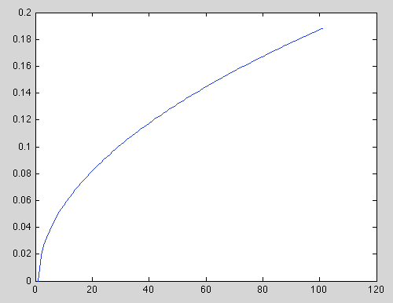With our current portfolio it is possible to calculate the Value-at-Risk. To be able to show the results in a graph, we will use the function proposed in [6] Mina J. et al. (2001) computation can be expanded to give us the VaR over time with by adding the variable T to the formulation, where T represents the number of days from today, and the result would be the amount that we would be β% sure it would not be exceeded:

The figure above shows a common application of Value-at-Risk, and how it behaves against time. However, as it was mentioned previously, the lack of convexity of the Value-at-Risk model does not allow for simple optimizations, so this model itself cannot be used for this purposes of portfolio optimization.

As it was mentioned previously, the accuracy of all the results, which mainly will consist in the parameter **π** to be learned, will be measured against the our index **I** with the Tracking Error formula introduced in the previous section, such as the offset between **I** and **Rπ** will define how accurate the results are.

## Simple Regression Models

It is now possible to test the L2-norm constraint under the same circumstances that were carried out in [5] Takeada A et al. (2000). The main objective of this previously mentioned paper is to show not only that the Norm Constrained Conditional-Value-at-Risk minimization is equal to an SVR minimization, hence ensuring optimal values, but as well showing that the NCCVaR is as reliable as CVaR minimization. For this, the NCCVaR minimization will be compared to the CVaR minimization proposed in Optimization of Conditional Value At Risk and the minimization on the absolute tracking value error, which will be referred to as abs.

To proceed, we will use the NCCVaR, CVaR and Abs to obtain their respective parameters **π** and compare their Tracking Error offset between one another. The lower the Tracking Error offset, the more accurate it is. Our minimization formula requires two input parameters that will need to be tweaked in order to obtain reliable results – these are namely β and C2.

The following task is to find the best value for these two variables in order to obtain reliable results. [Takeda 2010] proposes a value for β between 0.1 and 0.9, and C is chosen from , where k can be between 1 and 5. After carrying out several tests for a wide range of values between these two, it was discovered that the optimal value for β is 0.3 and for k is 5.

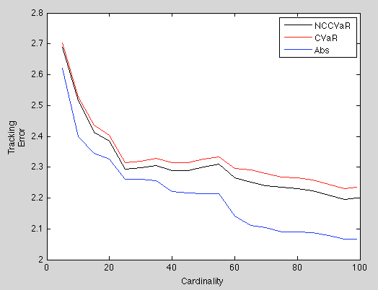We executed each of the models for subsets of assets from the model chosen at random with cardinalities {0, 5, 10, …, 95, 100}. We then calculated the Tracking Error between the Index portfolio and the Returns matrix multiplied by our learned parameters **π**. This gave us the results displayed in our figure to the right, in which we can observe the behavior of the Norm Constrained Conditional Value at Risk in black, the Conditional Value at Risk in red and the Absolute Tracking Error in blue.

As it can be observed, the tracking error is very low in all of the cases, and although Abs is slightly more accurate than the NCCVaR and CVaR, we can see that the Minimization on NCCVaR is extremely reliable, and can be used to expand for numerous applications. To which, one of our next steps is the individual feature selection models.

## Sparse Inducing Models

Given that with normal regression models it’s not possible to obtain subsets of data by simply modifying constraints, sparse inducing models are an attractive choice to force these characteristics. Now that the theory was covered in the background research, it is possible to take a practical perspective.

Most of these sparse models induce sparsity through a penalty coefficient consisting of an absolute sum of the weights, which push less important features towards zero values. This penalty is regulated through a coefficient, namely lambda, which controls how the magnitude of this penalization on the sum of weights.

The objective of this section is to collect observations of the effects of different values for this weighting coefficient to induce sparsity in our data, and to observe how efficient this solution is to achieve better goals.

### Simple Lasso model

The simple Lasso model in this paper is solved through two different iterative approaches – the LARS, FISTA and several primal and dual approaches, which are implemented by the CVX library that is used for these calculations.

In order to obtain a specific amount of zero values in the vector of weights it necessary to find the exact values for lambda in the Lasso regression formula. In this section, the Lasso model is implemented to both, our stochastic and market data for increasing values of lambda to observe the tracking error as the number of zero values increases.

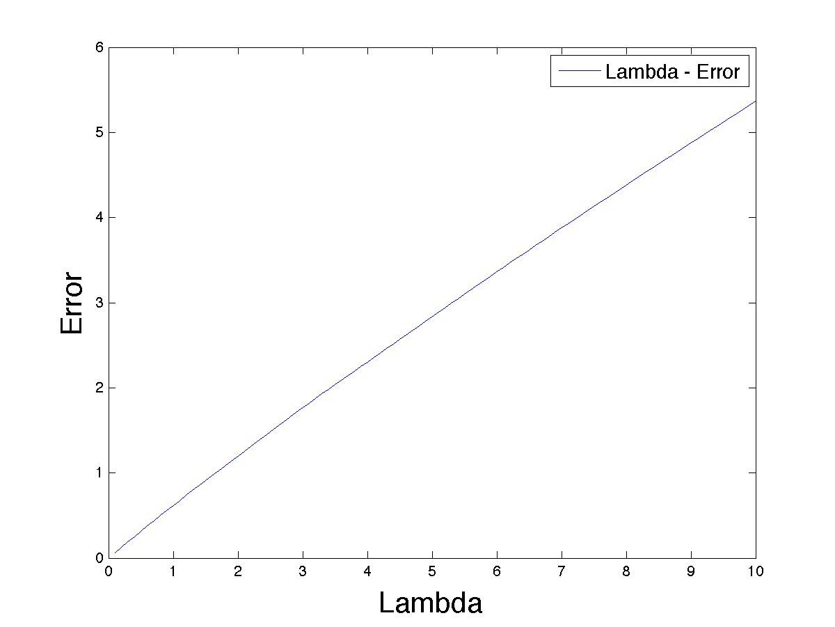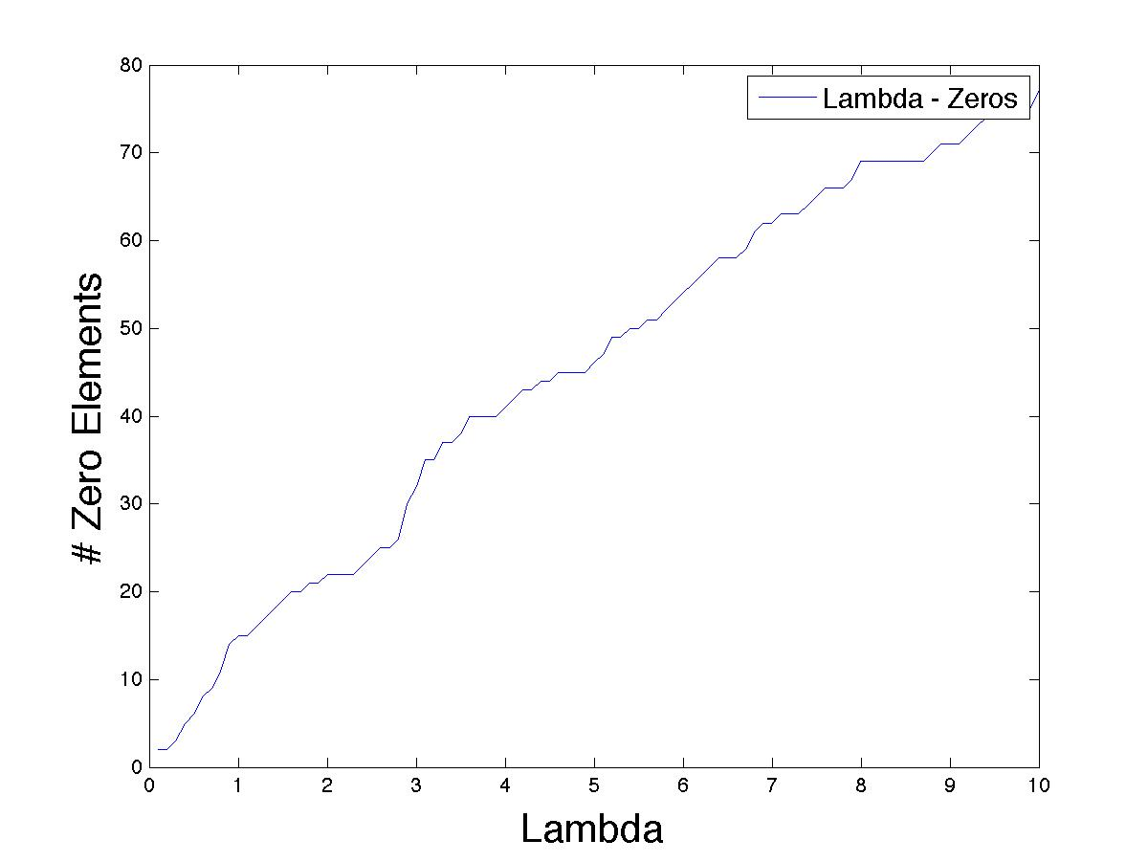Stochastic Data:

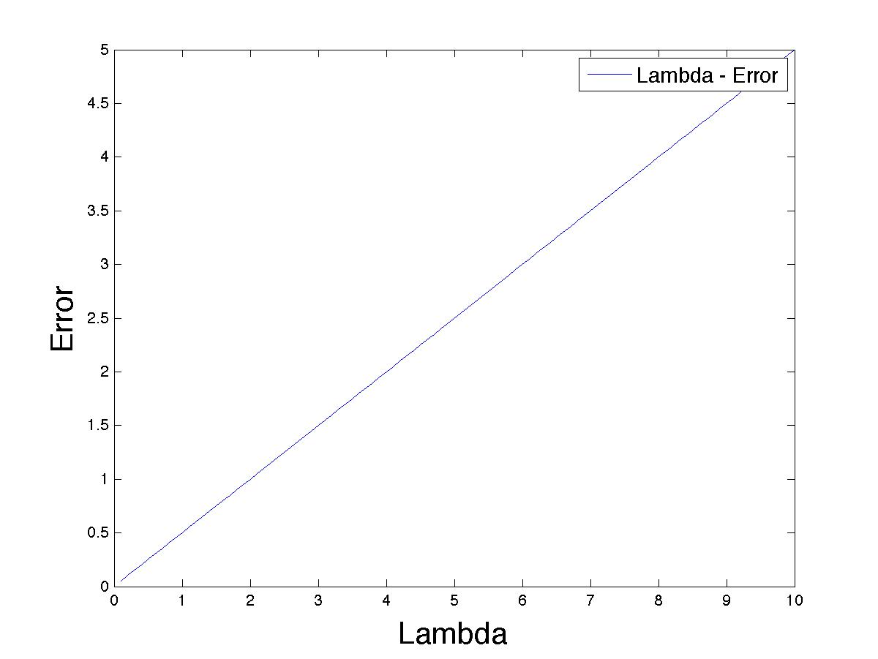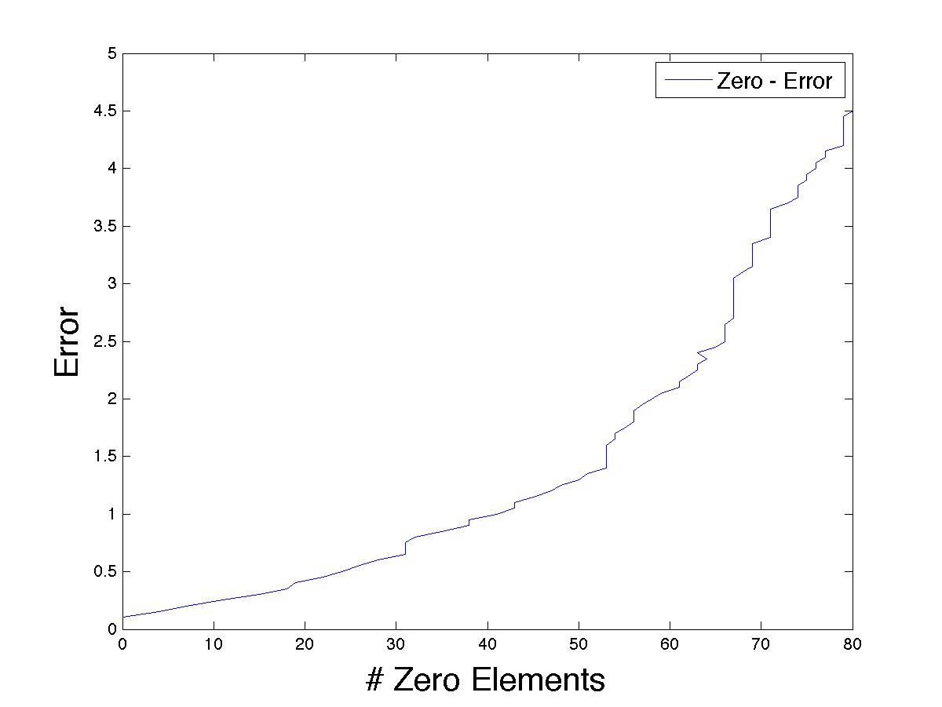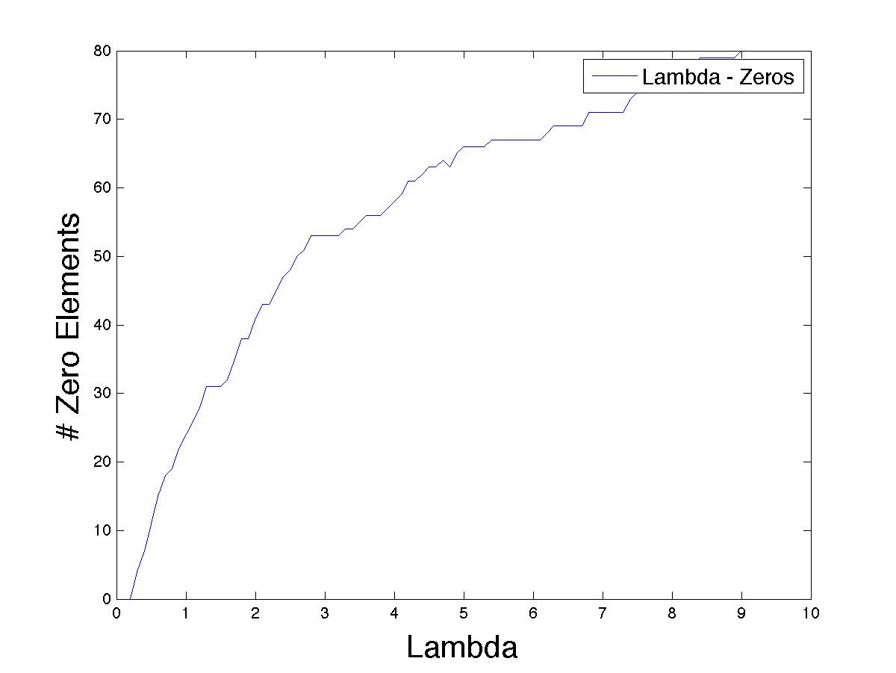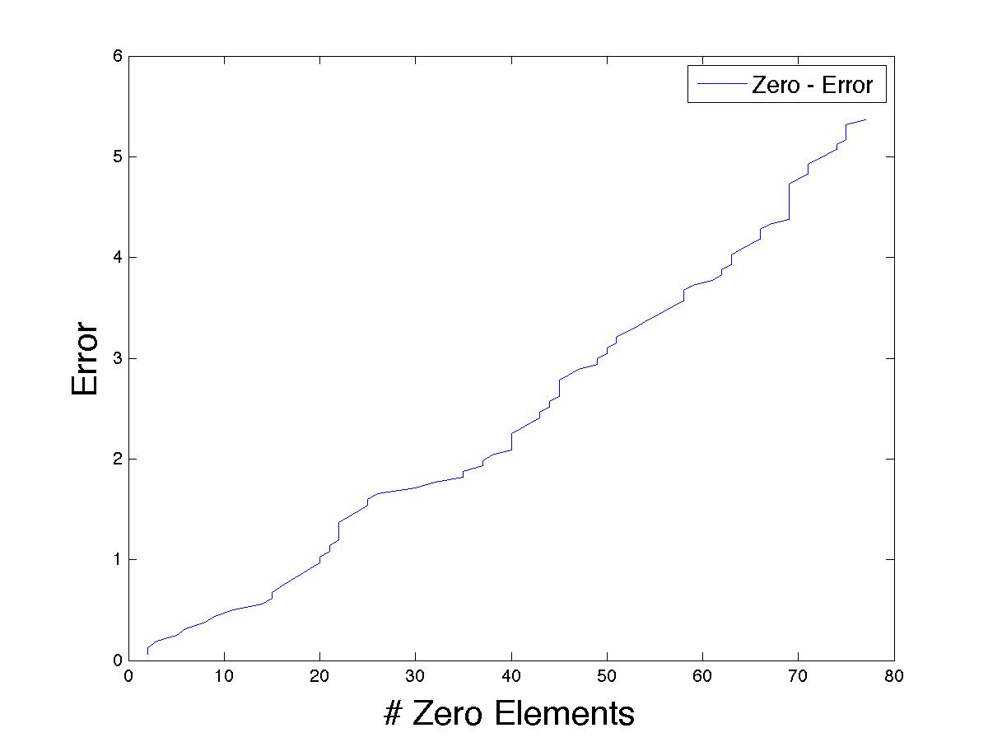

FTSE100 Data:

The results shown in figures [FIGURE] through [FIGURE] previous graphs were as expected in terms of their behavior (i.e. a logarithmic increase in the number of zeros as delta increases, as well as an exponential increase of the tracking error as the number of zeros increases), however what should be noticed, and will be revisited in more detail in the following section is the high tracking error values, which seem to increase much faster than in our previous section.

Likewise, numerical results emphasize these characteristics that were just mentioned. The numerical values in figure [FIGURE] have been reduced to only 10 iterations only to provide a practical perspective on results of sparse model applications, however, the experiments, including the previous graphs were ran with 100 iterations.

|  |  |  |  |  |  |  |  |  |
| --- | --- | --- | --- | --- | --- | --- | --- | --- |
| Stochastic Data | | | |  | Market Data | | | |
|  |  |  |  |  |  |  |  |  |
| **Lambda** | **# Zeros** | **Tracking Error** | **Elapsed** |  | **Lambda** | **# Zeros** | **Tracking Error** | **Elapsed** |
| 0 | 0 | 0.0003 | 15.3751 |  | 0 | 0 | 0.0003 | 2.8217 |
| 1 | 15 | 0.6186 | 9.3624 |  | 1 | 24 | 0.5025 | 1.7852 |
| 2 | 22 | 1.1998 | 10.1146 |  | 2 | 41 | 1.0007 | 1.9100 |
| 3 | 32 | 1.7666 | 8.6064 |  | 3 | 53 | 1.5004 | 2.1008 |
| 4 | 41 | 2.3039 | 8.6202 |  | 4 | 58 | 2.0003 | 1.8818 |
| 5 | 46 | 2.8342 | 8.4283 |  | 5 | 66 | 2.4998 | 1.7930 |
| 6 | 54 | 3.3626 | 9.1818 |  | 6 | 67 | 2.9997 | 1.8571 |
| 7 | 62 | 3.8769 | 8.4577 |  | 7 | 71 | 3.4996 | 1.8690 |
| 8 | 69 | 4.3807 | 8.4173 |  | 8 | 76 | 3.9995 | 1.8775 |
| 9 | 71 | 4.8779 | 8.4079 |  | 9 | 80 | 4.4993 | 1.8985 |

## Individual-Feature Selection

Now that several regression models have been applied to several subsets of data, it is possible to expand their application in our individual feature selection approach, where a forward selection model is implemented through a greedy approach to select a subset of stocks form a Market Index that minimizes Tracking Error – this is, that behaves as close as possible to the original market index.

The reason why a greedy approach is used is due to the exponential nature of the problem – it is necessary to select an ‘optimal’ combination of stocks from a set of at least 100 stocks (The average minimum for a financial Market Index). After this approach was implemented, it was confirmed that even small subsets require great amounts of time and computation.

### Algorithm

The algorithm used in this section is discussed in the 2.Background Research section, and the implementation can be found online in the repository. Briefly, the algorithm consist of a forward subset selection, where we initially begin with an empty subset of chosen stocks, we consider every single stock that is still available by adding them one by one and calculating the tracking error by using any regression model. The local-optimum will be chosen by selecting the stock that generated the smallest tracking error, and the algorithm iterates until there are no more available stocks to chose from, or the objective cardinality of our subset has been reached.

From the previous section, it was observed that in any situation, whether with large or small Market Index subsets, the most precise regression model (i.e. generated the lowest tracking error) is the ABS method. Although the ABS method was selected as the main model for individual-feature selection, the code implementation of this paper was written so that it is easy to choose the main regression model from a different range of models, which means that any regression model can be used.

It’s worth pointing out that the results in this section were limited to the time complexity of the problem, as although the greedy approach taken makes this problem possible to solve, it still shows extremely long execution times even when dealing with small sets of data.

### Feature-Selection Implementation

The algorithm was implemented by using the four main regression models in this paper. The greedy approach allowed us to choose subsets of stocks through local optimal decisions based in tracking error. In average, the time taken to select the locally optimal stock was 29.4115 seconds for our Market Data (100 features and 274 observations) and [REFERENCE (not reference, but just in case :P)] seconds for stochastic Market Data (200 features and 1000 observations).

Although it’s not possible to achieve a full search algorithm, and the execution time of this algorithm is extremely slow, the results were impressive in terms of the accuracy of the Index Tracking. As it can be observed in the results from stochastic data (figure [FIGURE]) and FPSE100 data (figure [FIGURE]), the values for Tracking Error are extremely low relative to all previous results.

|  |  |
| --- | --- |
| Macintosh HD:Users:axsauze:IdeaProjects:matlab:SPAMS:Graphs:feature_selection:stochastic_feature_selection_70.jpgStochastic Data | Macintosh HD:Users:axsauze:IdeaProjects:matlab:SPAMS:Graphs:feature_selection:ftse100_feature_seleciton_zoom.jpgMarket Data |

Once again it’s reassured that the abs regression model provides the best Index Tracking results, followed by least squares, CVaR and finally Ridge Regression. Our numerical results shown below in figures [FIGURE] and [FIGURE] also show a very low tracking error compared to our other implementations. This is also shown in the summary of data in the tables below.

|  |  |  |  |  |  |  |  |  |  |  |
| --- | --- | --- | --- | --- | --- | --- | --- | --- | --- | --- |
|  | **Tracking Error against Non-Zero Elements.** | | | | | | | | |  |
| Market Data (n = 100) | | | | |  | Stochastic Data (n = 200) | | | | |
| **Non-Zero** | **Abs** | **Squares** | **Ridge** | **CVaR** |  | **Non-Zero** | **Abs** | **Squares** | **Ridge** | **CVaR** |
| 1 | 1.6318 | 1.6318 | 1.6318 | 1.6318 |  | 1 | 5.3229 | 5.3229 | 5.3229 | 5.3229 |
| 7 | 0.5626 | 0.5856 | 0.5889 | 0.5922 |  | 12 | 4.1574 | 4.1659 | 4.6134 | 4.2446 |
| 13 | 0.3698 | 0.3968 | 0.4001 | 0.3897 |  | 23 | 3.4500 | 3.4780 | 4.0713 | 3.5702 |
| 19 | 0.2869 | 0.3087 | 0.3258 | 0.3042 |  | 34 | 2.8956 | 2.9539 | 3.6773 | 3.0781 |
| 25 | 0.2297 | 0.2589 | 0.2716 | 0.2515 |  | 45 | 2.5234 | 2.5609 | 3.2113 | 2.6830 |
| 31 | 0.1862 | 0.2134 | 0.2360 | 0.2222 |  | 56 | 2.1621 | 2.1958 | 2.8352 | 2.3756 |
| 37 | 0.1577 | 0.1839 | 0.2028 | 0.1894 |  | 67 | 1.8357 | 1.8781 | 2.5363 | 1.9910 |
| 43 | 0.1368 | 0.1548 | 0.1736 | 0.1731 |  | 78 | 1.5455 | 1.5954 | 2.2396 | 1.6544 |
| 49 | 0.1178 | 0.1338 | 0.1513 | 0.1574 |  | 89 | 1.2690 | 1.3086 | 1.9591 | 1.3769 |
| 55 | 0.0992 | 0.1156 | 0.1336 | 0.1517 |  | 100 | 1.0461 | 1.0838 | 1.6627 | 1.1712 |

In this previous two tables we can observe the tracking error when the first half of the elements in our market index are chosen. The tracking error shows to be extremely low compared to our other approaches, which proves to be a great method – this, without taking into account the huge time required for the computations, which will be discussed below

Before mentioning time complexity, it was very interesting to observe the behavior of each approach in terms of the stocks chosen, and the order in which they were chosen throughout the execution. For this we calculated the size of the union of each of the subsets of the four methods at each iteration of the algorithm. To make this clear, if on our 3rd iteration the stocks chosen are Abs={1,2,3}, Squres={2,3,4}, Ridge={2,3,5}, CVaR={2,3,6}, then the union of this subsets is {2,3}, which means that there are two stocks that have been chosen in all subsets. This is shown in figure [FIGURE], where it is possible to observe that for all our iterations, at least half of all the subsets consisted of the same stocks, and given that we are considering the four sets at the same time (rather than just comparing pairs), this truly reassures that some stocks really have much more powerful tracking potential than others, and there really is an optimal subset that can be found from subset selection models.

|  |  |
| --- | --- |
| **Percentage of Same Elements in Subsets** | |
| Macintosh HD:Users:axsauze:IdeaProjects:matlab:SPAMS:Graphs:feature_selection:stochastic_zeros_same.jpgStochastic Data | Market Data  Macintosh HD:Users:axsauze:IdeaProjects:matlab:SPAMS:Graphs:feature_selection:ftse_zeros_same.jpg |

Something that really needs to be mentioned is the time taken for computing these results. Although the greedy approach taken made the computations of this section possible, it still does not account fully for the huge time complexity of the problem. The Market Data only consisted of 100 elements, and it took over one hour to compute – the stochastic data, in the other hand, with just a number of elements twice as large as our market data, took over 2 days to compute. Given that 100 is the minimum number for a market index, this approach would be infeasible in the real financial world when speed is a real concern.

## Group Models

Group models is one of the core topics in this paper, as it aims to find the effects of using underlying knowledge of the financial instruments to consider these as groups. There are several approaches in this section to test the effectiveness of this approach, and whether this is a better approach than the ones taken previously.

Similar to our previous section, a model selection approach will be taken, where optimal solutions are believed to be reachable assuming that grouped data does not exceed a number greater than 20 groups. The reason for this is because a full-search approach is taken, rather than a greedy one, as a full-path search is reachable when the number of features to select from are less.

This section is approached in several different ways. Groups and clusters of data are selected in various ways. Market Industry and Market Sector of the individual stocks are important choices to consider in the implementation, however it is also important to consider other approaches that can allow us to group the stocks without prior knowledge or information on these. We assume that groupings in data contain correlations in some way – for this, we use a several clustering methods to find such groupings – our main approach is through spectral clustering based in K-nearest neighbor and K-means. The spectral clustering implementation gives us the ability to find clusters of data based on a correlation matrix computed for each dataset. These groups are then taken as inputs, and data is then processed with these assumptions.

### Group Selection

The method proposed for the individual feature selection in the previous section is expanded into group selection, where instead of selecting individual features, groups are selected based on the training error of each chosen subset.

Initially, stochastic and market data are compared side by side – groups are chosen through our spectral clustering approach with a number of 5 and 8 groups, which would simulate the groupings that would be generated through prior knowledge (e.g. industry type, sector, etc).

This approach is somewhat limited due to the exponential nature of the full-search approach taken to find the optimum solution for this group selection problem. This limitation however should not be a problem in this implementation, as there should not be cases where we encounter numbers of groups greater than 15 (as greater numbers would result in an impossible number of iterations required). If this is the case, other approaches must be considered.

|  |  |
| --- | --- |
| Macintosh HD:Users:axsauze:IdeaProjects:matlab:SPAMS:Graphs:group_selection:stochastic_zero_error.jpgStochastic Data (5 groups) | Market Data (5 groups)  Macintosh HD:Users:axsauze:IdeaProjects:matlab:SPAMS:Graphs:group_selection:ftse100_zero_error.jpg |

|  |  |
| --- | --- |
| Stochastic Data (8 groups)  Macintosh HD:Users:axsauze:IdeaProjects:matlab:SPAMS:Graphs:group_selection:stochastic_zero_error_7groups.jpg | Market Data (8 groups)  Macintosh HD:Users:axsauze:IdeaProjects:matlab:SPAMS:Graphs:group_selection:ftse100_zero_error_7groups.jpg |

Like in previous sections, the numerical data displayed was limited to only a subset of the full results, as this is enough to show the most important details, which include the Tracking Error dependent on sparsity of the subset.

|  |  |  |  |  |  |  |
| --- | --- | --- | --- | --- | --- | --- |
| Stochastic Data (8 Groups) | | |  | | Market Data (8 Groups) | |
|  |  |  | |  |  |  |
| **# Zero Elements** | **Error** |  | |  | **# Zero Elements** | **Error** |
| 0 | 0.0000 |  | |  | 0 | 0.0000 |
| 21 | 1.2303 |  | |  | 11 | 0.0615 |
| 42 | 1.7481 |  | |  | 20 | 0.1071 |
| 66 | 2.1601 |  | |  | 30 | 0.1293 |
| 90 | 2.6477 |  | |  | 40 | 0.1745 |
| 105 | 3.0955 |  | |  | 53 | 0.4213 |
| 110 | 3.2069 |  | |  | 60 | 0.4910 |
| 134 | 3.5557 |  | |  | 70 | 0.4716 |
| 152 | 4.2498 |  | |  | 80 | 0.7315 |
| 179 | 4.6964 |  | |  | 90 | 1.1174 |
| 197 | 6.3528 |  | |  | 97 | 1.7549 |

What should be noticed from this graphs is the aggressive variations in Tracking Error, which seems to sometimes decrease even when a higher number of zeros is present. Given that this algorithm takes full-search approach rather than a greedy approach, it evaluates every possible combination of groups. Each jump in the data line represents a specific combination of the groups available.

Even though the tracking error is slightly worse, the faster execution times of this algorithm compared to the feature selection approach might make this model an interesting choice to consider for portfolio tracking.

## Sparse Group Models

This following sections contain the implementation of sparse group models in financial data.

### Group Lasso

The group lasso provides exactly the same sparsity effects than its equivalent single-feature counterpart – the difference is that the sparsity of this model is applied to the groups as a whole, rather than to each individual feature.

The algorithm implemented is described in the Background Research section, which was perhaps the most challenging section in this project. The algorithm was implemented with some help from the CVX toolbox which provides the iterative algorithm to solve the equation provided.

The solution proposed proved to be more accurate than the closed-source solution provided by the SPAMS toolbox – however, results from this library are also displayed further.

Similar to our implementation with the individual-feature Lasso regression model, we are interested in the behavior of the tracking error as the number of zeros increases – that is, as the value of lambda increases.

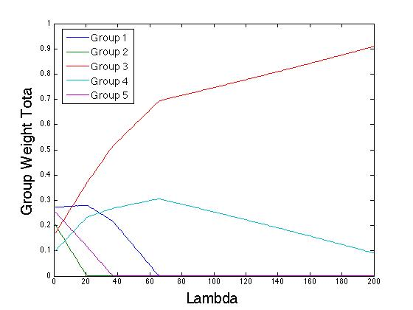

It is very worth mentioning that similar to the individual version of this model – as the value of lambda increases, the weights tend to grow towards the group with the highest correlation to our target data as shown in figure [FIGURE] which was drawn from our data. As the value of lambda decreases, our results become more similar to the ones from our Abs and Squares models.

The initial results, shown below in figures [FIGURE] to [FIGURE], include the behavior of the Tracking Error against our Lambda and Number of Zeros. For both, Stochastic and Market data.

|  |  |  |
| --- | --- | --- |
| **Lambda** | **Zeros** | **Error** |
| 0 | 0 | 0.026787871 |
| 0.05 | 47 | 2.646495744 |
| 0.1 | 47 | 5.267187419 |
| 0.15 | 47 | 7.895967048 |
| 0.2 | 47 | 10.53292391 |
| 0.25 | 72 | 10.96675929 |
| 0.3 | 47 | 15.80435922 |
| 0.35 | 47 | 18.44012701 |
| 0.4 | 47 | 21.07673251 |
| 0.45 | 72 | 20.79837242 |
| 0.5 | 72 | 23.67492887 |
| 0.55 | 72 | 27.46705371 |
| 0.6 | 72 | 28.88447056 |
| 0.65 | 72 | 30.85360365 |
| 0.7 | 47 | 36.89241989 |
| 0.75 | 72 | 34.81851777 |
| 0.8 | 72 | 38.38139935 |
| 0.85 | 47 | 44.8010006 |
| 0.9 | 72 | 45.77971577 |
| 0.95 | 72 | 44.32525003 |
| 1 | 72 | 48.23389835 |

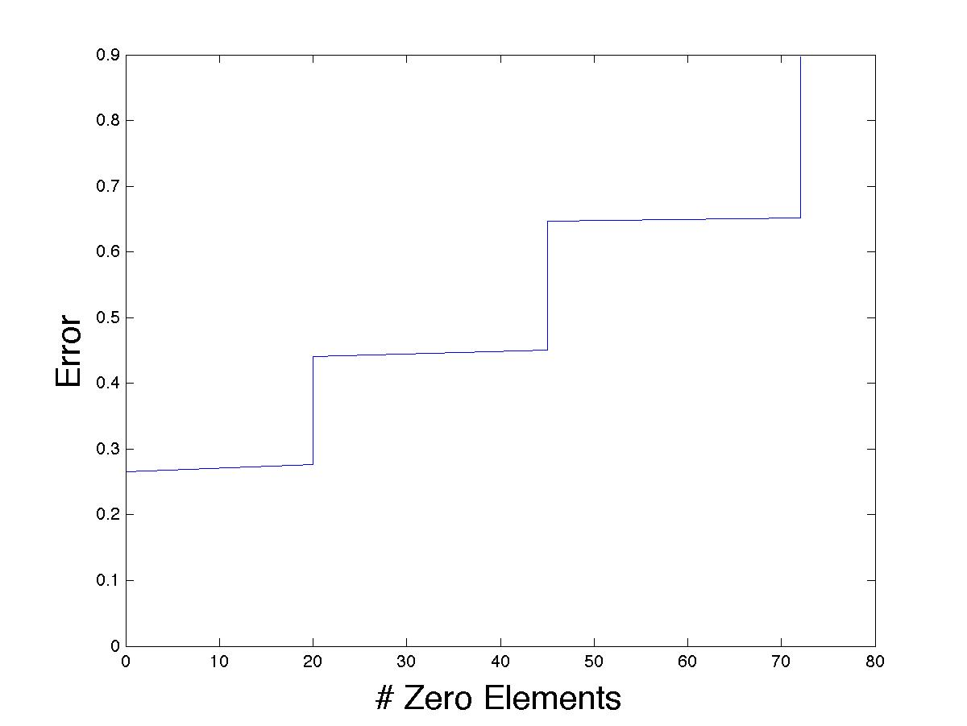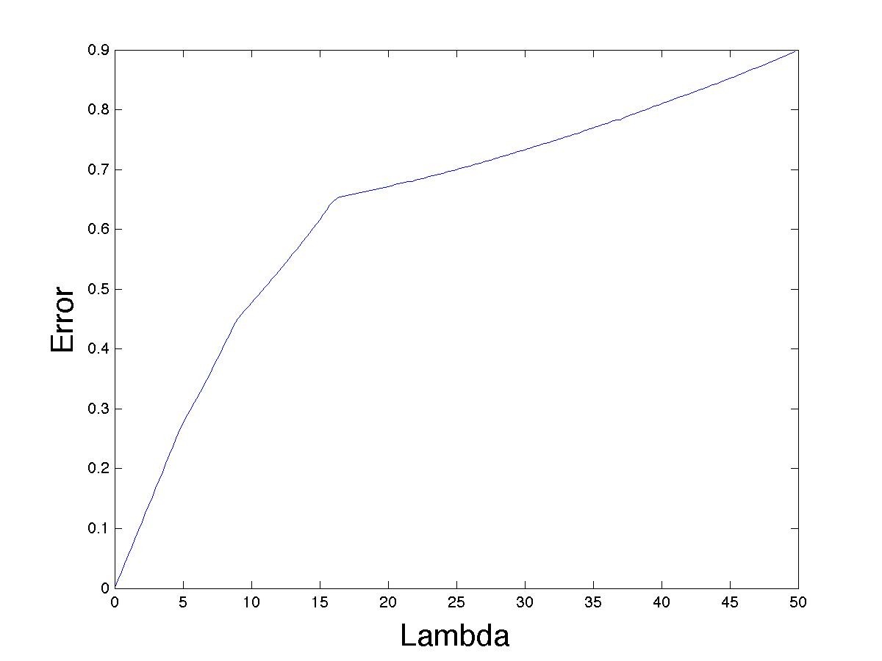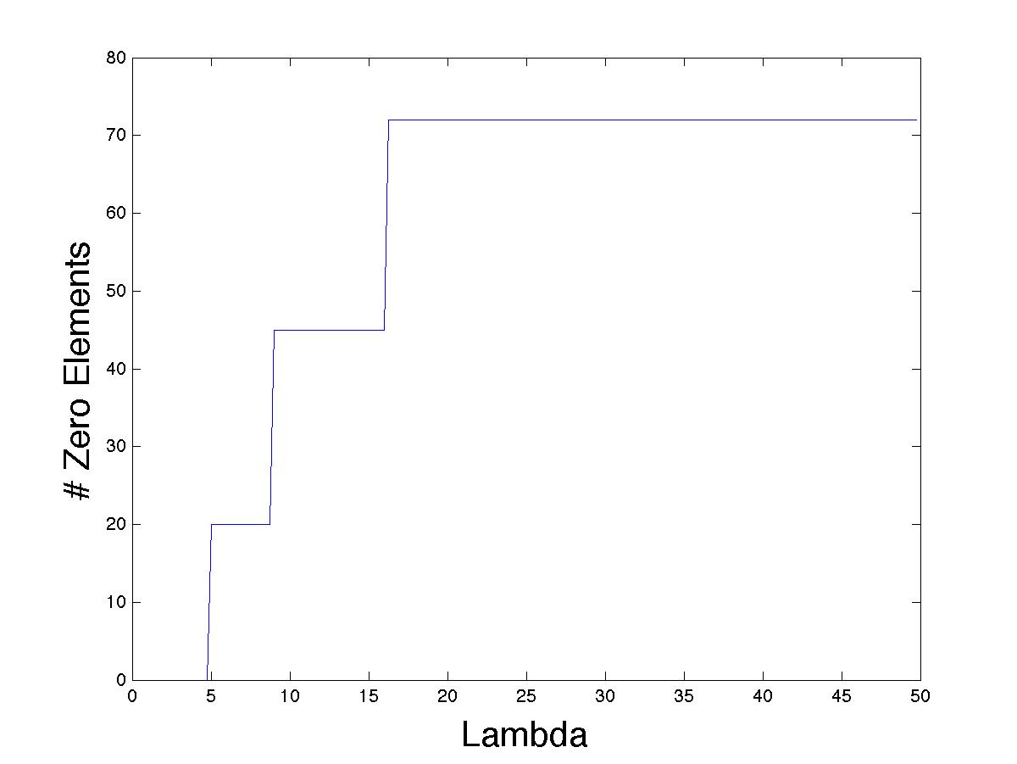

A big inconvenience with this model is that the L2-norm constraint imposed in the groups force all the weights to be the virtually same within each group – and when one of the group tends to zero, all it’s values will become zero immediately as well. This disadvantage can be overcome with the sparse group model in the next section.

Our second approach was tested with the black box approach provided by the SPAMS library. The results achieved had a much lower accuracy, but nevertheless, they showed the same behavior.

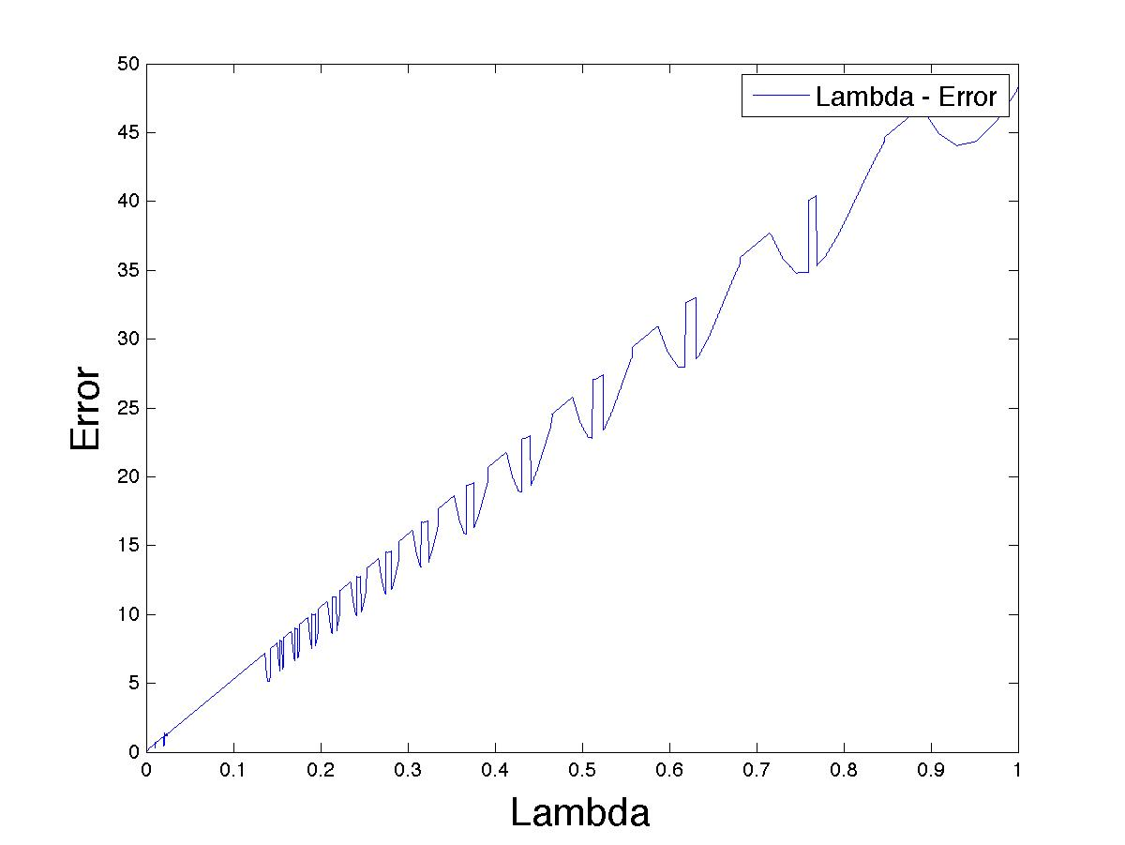

The irregular pattern in figure [FIGURE] might seem confusing on first sight, but the behavior present is very similar to the one in the previous implementation. This can be observed in the table of summarized data. The algorithm that the SPAMS library provides causes more violent changes in group data, which cause the big jumps in the data line. It can also be noticed that there are drastic changes in the number of zeros and error.

### Sparse Group Lasso

The problem with the normal group lasso model is that the L2 constraint induces sparsity only between groups, but not within groups. What this means is that if one element in a group becomes zero, all the elements in that group would become zero. The Sparse Group Lasso algorithm comes in handy, as it introduces again the L1-norm constraint found in the single-feature Lasso model which induces sparsity within the groups.

It should be noted that lambda-1 and lambda-2 needed to be tweaked a lot in order to obtain the best results. The behaviour of the model varies a lot depending on the value of these variables. This is why a good understanding should be acquired on these values, as the optimum values found were very specific, but these will also provided a great insight on the potential of this model when implemented in financial datasets.

Initially, the behaviours observed for basic inputs were very much as expected - A zero value of lambda-1 would cause the model to behave like the simple Lasso regression model. A zero value of lambda-2 would make the model behave like the group lasso. What draw our attention was when both values are set to proportionately equal – intuitively this would force all groups towards the same values within groups (trying to achieve sparsity in group level), while inducing sparsity to all features. This surprisingly resulted in no sparsity induced at all, and instead, all our values were drawn to an equal value which is their relative percentage of weighting on the group. This will be discussed in more detail further.

We initially implement the model in our data to observe the desired effect – it important to point out that the sparse group lasso implementation is in a way a simple lasso implementation with grouping weightings dependent on our lambda-2 value.

To begin, we observe the effect of variable values of the lambda-1 group sparsity coefficient over a fixed lambda-2 feature sparsity coefficient. The initial lambda-2 coefficient is set to a value large enough to show induce sparsity effects in our results such that we are able to see how this sparsity is affected. Our implementation was executed with a fixed lambda-2 of value 24, as it can be observed, with a zero lambda-1 it is expected that the behaviour of the model is exactly the same to the Lasso regression model - the sparsity achieved initially was of 59 zeros, with a tracking error of 0.44, and the values change as the value of lambda-1 increases.

|  |  |  |
| --- | --- | --- |
|  | Market Data |  |
| Tracking Error as Lambda-1 Increases | Number of Zeros per group as Lambda 1 increases | Total Number of Zero Elements as Lambda 1 increases |
| Macintosh HD:Users:axsauze:IdeaProjects:matlab:SPAMS:Graphs:sparse_group_lasso:fixed_l2:ftse_fixl2_lambda_error.jpg | Macintosh HD:Users:axsauze:IdeaProjects:matlab:SPAMS:Graphs:sparse_group_lasso:fixed_l2:ftse_fixl2_group_zeros.jpg | Macintosh HD:Users:axsauze:IdeaProjects:matlab:SPAMS:Graphs:sparse_group_lasso:fixed_l2:ftse_fixl2_lambda_zeros.jpg |

Figures [FIGURE] to [FIGURE] show the behaviour mentioned previously. Initially, the model provides the same results as a Lasso regression model, with a sparsity of 59 zeros distributed without taking into consideration groupings as inputs. However, as the value of Lambda-1 increases, namely the coefficient that controls the group sparsity characteristic, we can observe that the feature level sparsity decreases until no sparsity is present in the array.

What is interesting is the characteristic of this model when both Lambdas become of similar proportion. This can be observed in figures [FIGURE] and [FIGURE] below.

|  |  |
| --- | --- |
| Weights of Individual Features as Lambda-1 Increases | Sum of Weights of all Features in each group as Lambda-1 Increases |
| Macintosh HD:Users:axsauze:IdeaProjects:matlab:SPAMS:Graphs:sparse_group_lasso:fixed_l2:ftse_fixl2_lambda_features.jpg | Macintosh HD:Users:axsauze:IdeaProjects:matlab:SPAMS:Graphs:sparse_group_lasso:fixed_l2:ftse_fixl2_lambda_group_sums.jpg |

To begin with, figure [Figure] on the left shows the behaviour of every weight for each individual feature as lambda-1 increases with a fixed lambda-2. In both figures, it can be observed that, as with a normal Lasso model (i.e. when lambda-1 = 0), many elements start with a zero value, and only values with higher correlation have a value larger than zero. However, as Lambda-1 increases towards lambda-2, all these values are pulled up from zero, and pulled down from higher values. Figure [Figure] on the right gives more insight on this behaviour. Initially, the sum of weights of groups are not controlled, however, as Lambda-1 increases, it is possible to observe that the sums tend towards a specific value. This value is initially the percentage it’s group size comprises from the total number of data features (e.g. if there are n=100 features, and group g has size 10, then its sum would tend towards 0.1).

Our final point in regards to the behaviour of Lamda-1 and Lambda-2 is their joint behaviour – this is, as both values increase towards infinity. The results of this are also very interesting, and intuitions are provided on first sight on figures [FIGURE] and [FIGURE].

|  |  |
| --- | --- |
| Weights of Individual Features as Lambda-1 and Lambda-2 Increase | Sum of Weights of all Features in each group as Lambda-1 and Lambda-2 Increase |
| Macintosh HD:Users:axsauze:IdeaProjects:matlab:SPAMS:Graphs:sparse_group_lasso:ftse_lambdas_features.jpg | Macintosh HD:Users:axsauze:IdeaProjects:matlab:SPAMS:Graphs:sparse_group_lasso:ftse_lambdas_sumgroups.jpg |

Figures [FIGURE] and [FIGURE] show the same situation as the previous figures, however, these show the behaviour of the model as Lambda-1 and Lambda-2 tend towards infinity. It can be observed from both figures that the individual weights tend to the same value 1/p within each group, where p is the size of the group, and the sum of the weights in each group tend towards 1/g where g is the number of groups.

With this, we can approach our portfolio optimization problem more efficiently, where in this case we would often prefer to have a sparse portfolio, where our risk is spread over groups of different correlations in order to decrease risk. From our previous definitions, we can intuitively see that this can be achieved with a larger lambda-2 to induce feature sparsity, and a lambda-1 coefficient to introduce regularization to induce sparsity as a group level and to balance sums of weights between groups in order to spread the risk in different groups.

The experiments observed in this section comprise of a lambda-2 = {0.01, …, 20 }, with a lambda-1 = lambda-2/1,000.

|  |  |  |  |
| --- | --- | --- | --- |
| Market Data (Sparse Group Model) | | | |
| **Lambda-1** | **Lambda-2** | **Zeros** | **Error** |
| 0 | 0 | 0 | 0.0000 |
| 5.0E-05 | 0.05 | 0 | 0.0130 |
| 1.0E-03 | 1 | 20 | 0.1715 |
| 2.0E-03 | 2 | 33 | 0.2705 |
| 3.0E-03 | 2.95 | 48 | 0.3447 |
| 4.0E-03 | 4 | 51 | 0.4003 |
| 5.0E-03 | 5 | 55 | 0.4483 |
| 6.0E-03 | 6 | 59 | 0.4925 |
| 7.0E-03 | 7 | 61 | 0.5317 |
| 8.0E-03 | 8 | 63 | 0.5700 |
| 9.0E-03 | 9.05 | 67 | 0.6091 |
| 1.0E-02 | 9.95 | 68 | 0.6397 |

Once again only a subset of data was chosen for the table – it can be observed that the tracking error obtained is slightly lower than the observed in the simple lasso model.

However it should be emphasized that in this section we are focusing more in the concern of being able to spread risk throughout correlated groups of data.

# Analysis

In finance it is very important

## Testing Environment

## Algorithms Used

# Expansion

The top-down approach presented in the previous section is also followed in this section. The technical

# Testing

The top-down approach presented in the previous section is also followed in this section. The technical

# Critical Evaluation

The top-down approach presented in the previous section is also followed in this section. The technical progress up to this point includes thorough testing of the components of the L0-L2-norm model.

All the computations were carried out in a 2.9 GHz Intel Core i7 computer with 8GB 1600 MHz DDR3 RAM and OSX 10.8.5. The algorithms were written and executed in Matlab R2009b with the help of a third party plugin called CVX, which provides a toolbox for convex optimizations.

# Conclusion

The top-down approach presented in the previous section is also followed in this section. The technical

# Plan of Remaining Work

Now that most financial, statistical and algorithmic concepts have been understood, and an acceptable level of programming has been obtained in Matlab together with the statistical libraries required for this application, it is possible to carry the project further.

Currently, the objective is to improve the efficiency and reliability of the current application of the L0+L2-norm model over the winter break so that during part 2 of the project the focus can be on expanding the model into further applications.

As it was mentioned in the introduction, the main goal to achieve as soon as an efficient and reliable algorithm is devised is to apply the L0+L2-norm model in distinct financial instruments, such baskets of currencies, or commodities. In order to achieve this, a more concise understanding will have to be achieved in these financial instruments, and slight modifications will have to be made in these models to support specific characteristics like seasonality in commodities.

Once the application of the model is expanded to either commodities or currencies, the focus will be high frequency data. In order to be able to process high-frequency data, and improvement in the efficiency of the algorithm without substantial loss of accuracy will be crucial, as currently the implementation of the model takes an extremely long time to compute. Different programming languages such as C++ are being considered for the expansion of this model.

Finally, real-time data feeds are something very important – a way to update the current state of the model as new data comes in would be a huge advancement, but as it was mentioned, currently our main two concerns are the efficient and reliable application of the model and the potential expansion in distinct financial instruments.

# References

|  |  |
| --- | --- |
| [0] | Takeda, A., Niranjan, M., Gotoh, J. Y., & Kawahara, Y. (2013). Simultaneous pursuit of out-of-sample performance and sparsity in index tracking portfolios. *Computational Management Science*, *10*(1), 21-49. |
| [1] | Markowitz, H. (1952). Portfolio selection\*. *The journal of finance*, *7*(1), 77-91. |
| [2] | Philippe J. (1996) Risk2: Measuring the Risk in Value at Risk. Financial Analysts Journal , Vol. 52, No. 6 (Nov. - Dec., 1996), pp. 47-56 |
| [3] | Rockafellar, R. T. (1997). *Convex analysis* (Vol. 28). Princeton university press. |
| [4] | Rockafellar, R. T., & Uryasev, S. (2000). Optimization of conditional value-at-risk. *Journal of risk*, *2*, 21-42. |
| [5] | Takeda, A., Gotoh, J. Y., & Sugiama, M. (2010, August). Support vector regression as conditional value-at-risk minimization with application to financial time-series analysis. In *Machine Learning for Signal Processing (MLSP), 2010 IEEE International Workshop on* (pp. 118-123). IEEE. |
| [6] | sss, J., & Xiao, J. Y. (2001). Return to RiskMetrics: the evolution of a standard. *RiskMetrics Group*. |
| [7] | Brodie, J., Daubechies, I., De Mol, C., Giannone, D., & Loris, I. (2009). Sparse and stable Markowitz portfolios. *Proceedings of the National Academy of Sciences*, *106*(30), 12267-12272. |